JS Advanced: Exam 19 December 2016

Problems for exam preparation for the “JavaScript Advanced” course @ SoftUni. Submit your solutions in the

SoftUni judge system at https://judge.softuni.bg/Contests/375/.

Problem 1. Move Towns Up / Down (Simple DOM Interaction)

You are given the following HTML code:

move-up-down.html

<!-- JS Advanced Exam @ SoftUni - 19-Dec-2016 -->

<!DOCTYPE html> <html>

<head>

<meta charset="UTF-8"> <title>Move Up / Down</title> <style>

select { width: 70px }

.block { display: inline-block; vertical-align: top }
#btnUp { display: block; margin-top: 18px }

#btnDown { display: block; margin-top: 10px } </style>

<script src="https://code.jquery.com/jquery-3.1.1.min.js"></script> </head>

<body>

<div class="block">

<select id="towns" size="5"> <option>Sofia</option> <option>Varna</option> <option>Plovdiv</option> <option>Ruse</option>

</select> </div>

<div class="block">

<button id="btnUp" onclick="move(-1)">&uparrow;</button> <button id="btnDown" onclick="move(+1)">&downarrow;</button>

</div>

<script>

function move(direction) {
// TODO: …
}

</script> </body> </html>

Your Task

Write the missing JavaScript code to make the arrow buttons work as expected.


© Software University Foundation (softuni.org). This work is licensed under the CC-BY-NC-SA license. Follow us:  Page 1 of 3
- The [↑] button move the selected item up in the list. If no item is selected, it should do nothing.

- The [↓] button should move the selected item down in the list. If no item is selected, it should do nothing.

Note: When an item is selected, it has the property selected.

Examples
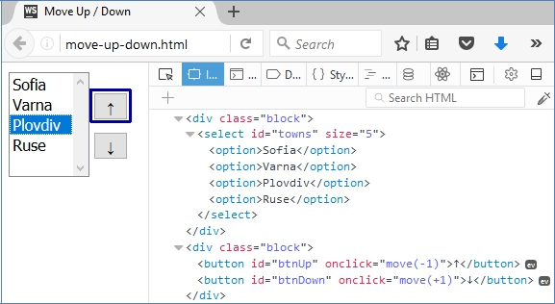

↓
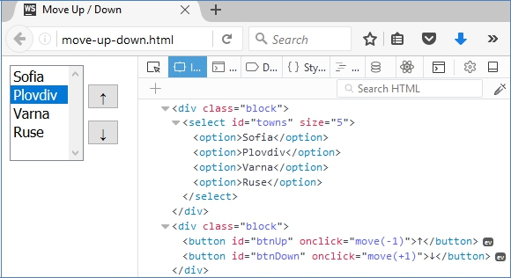

© Software University Foundation (softuni.org). This work is licensed under the CC-BY-NC-SA license. Follow us: Page 2 of 3
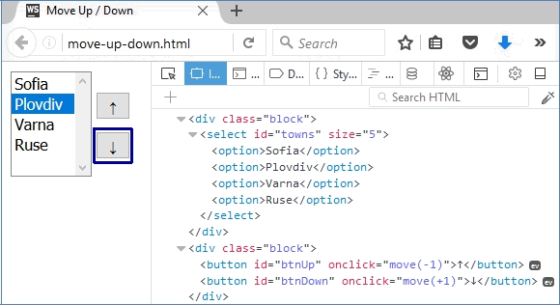

↓
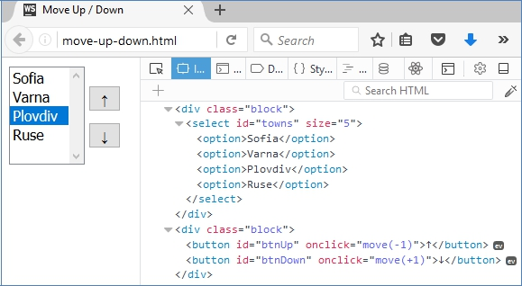

Submission

Submit your move() function as “JavaScript code (DOM unit tests)”.

© Software University Foundation (softuni.org). This work is licensed under the CC-BY-NC-SA license. Follow us: Page 3 of 3

